Lab 5

Rong Guo

C00290890

Catalog

Apply weight-based routing 3

Route to version 1 4

Test the new routing configuration 7

Route based on user identity 8

Injecting an HTTP delay fault 9

Testing the delay configuration 11

Fixing the bug 11

Injecting an HTTP abort fault 12

Testing the abort configuration 13

Configuring the circuit breaker 13

Adding a client 14

Tripping the circuit breaker 15

Apply weight-based routing

To get started, run this command to route all traffic to the v1 version

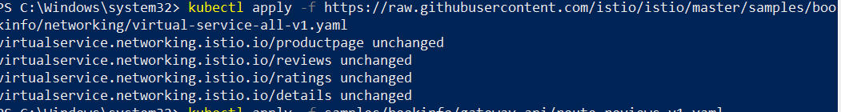



Transfer 50% of the traffic from reviews:v1 to reviews:v3 with the following command:

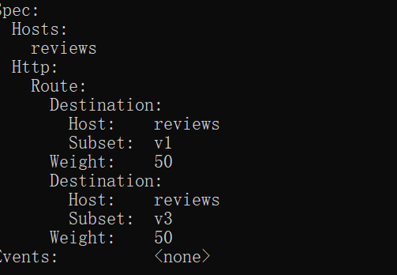

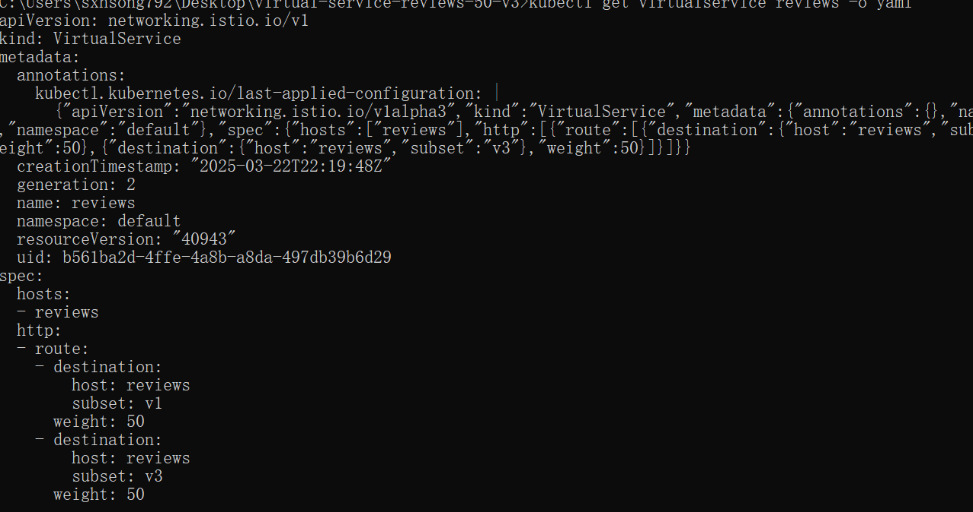

Assuming you decide that the reviews: v3 microservice is stable, you can route 100% of the traffic to reviews: v3 by applying this virtual service

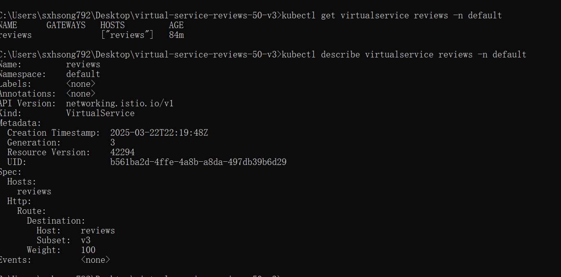

Refresh the /productpage several times.



Route to version 1

Save the YAML configuration to a file

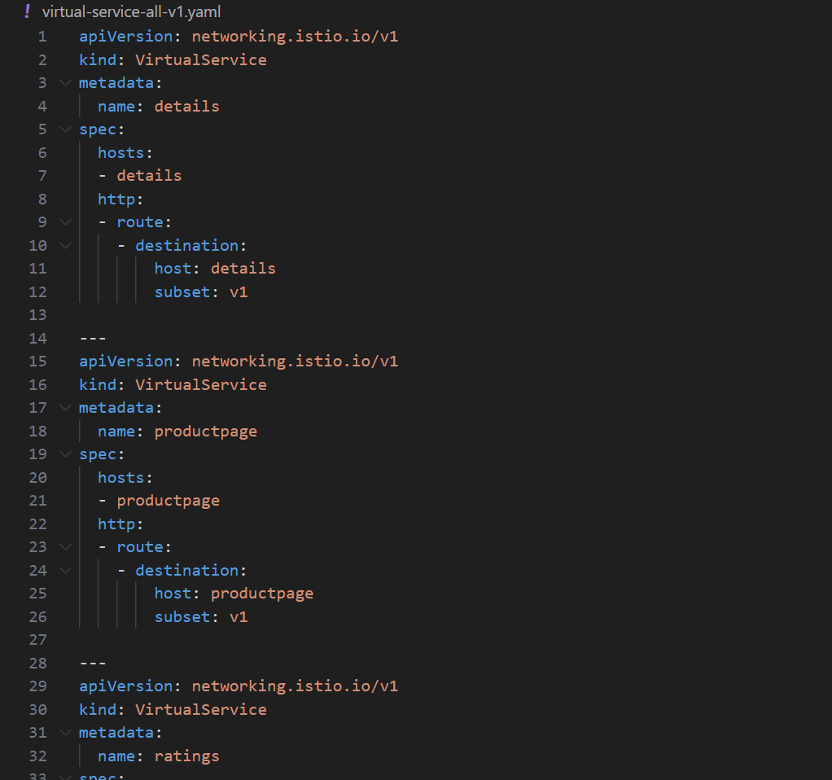

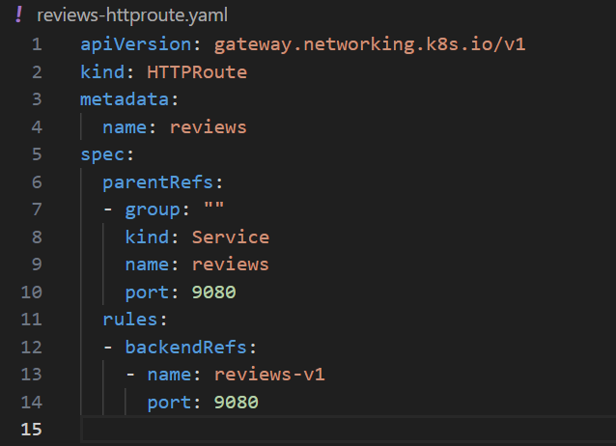

Apply the configuration file

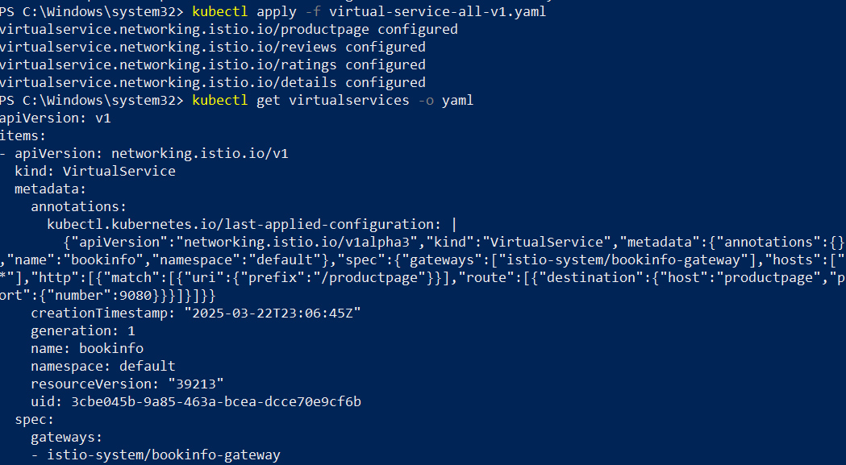

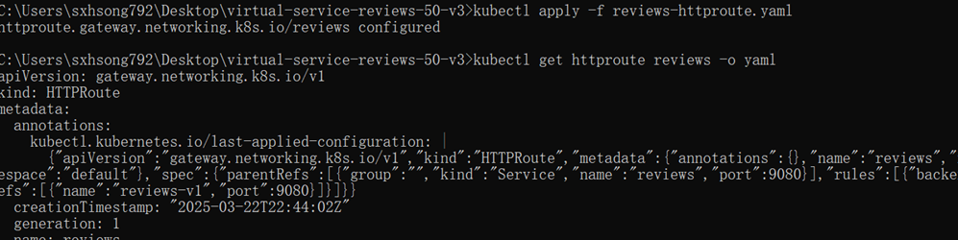

Verify the configuration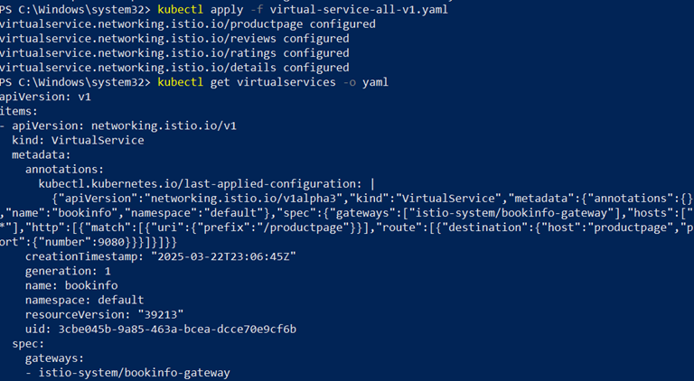

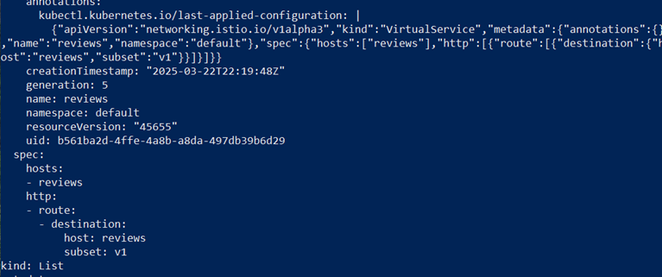

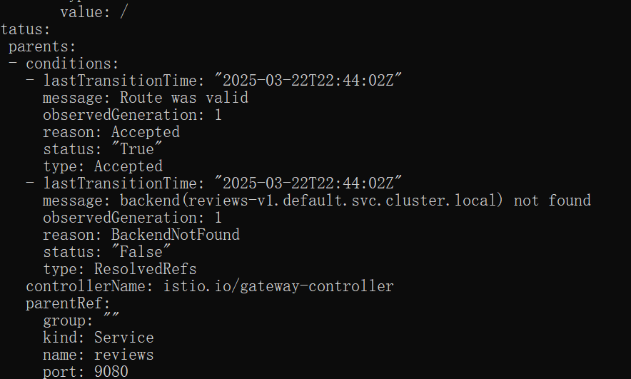

Test the new routing configuration

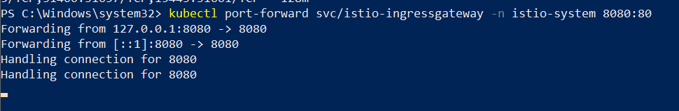



Route based on user identity

Save the YAML configuration to a file

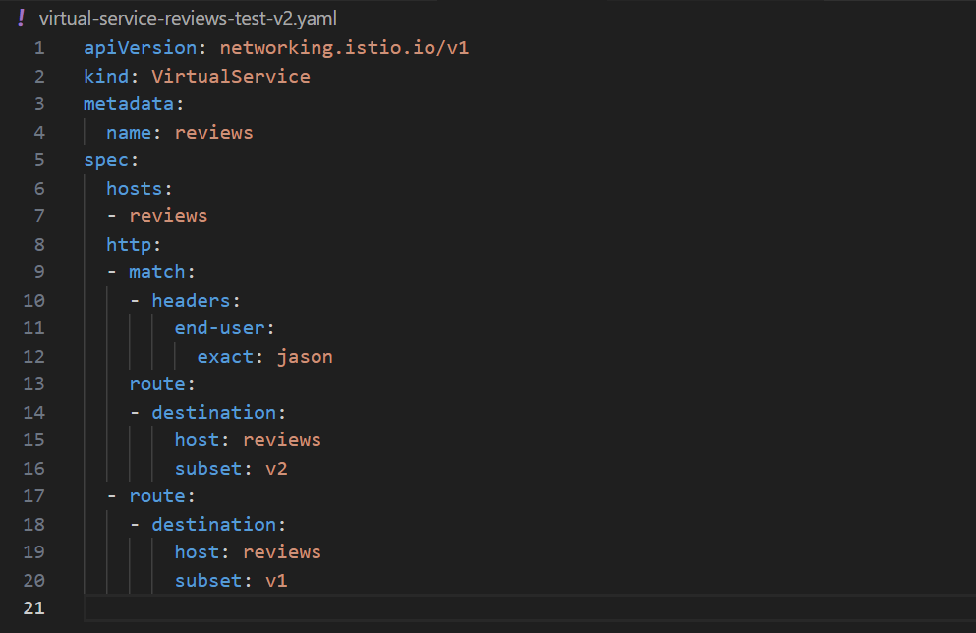

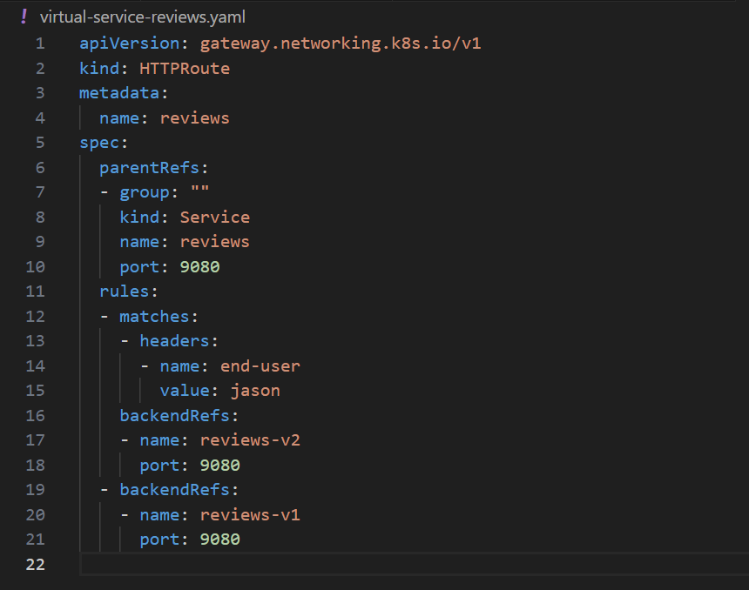

Apply the configuration file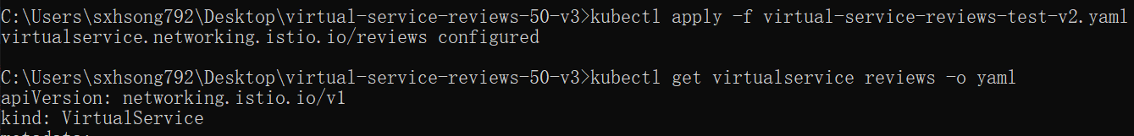



Verify the configuration

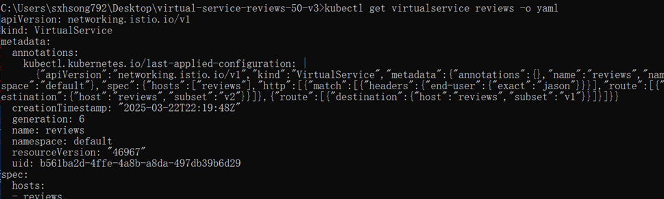

View Jason

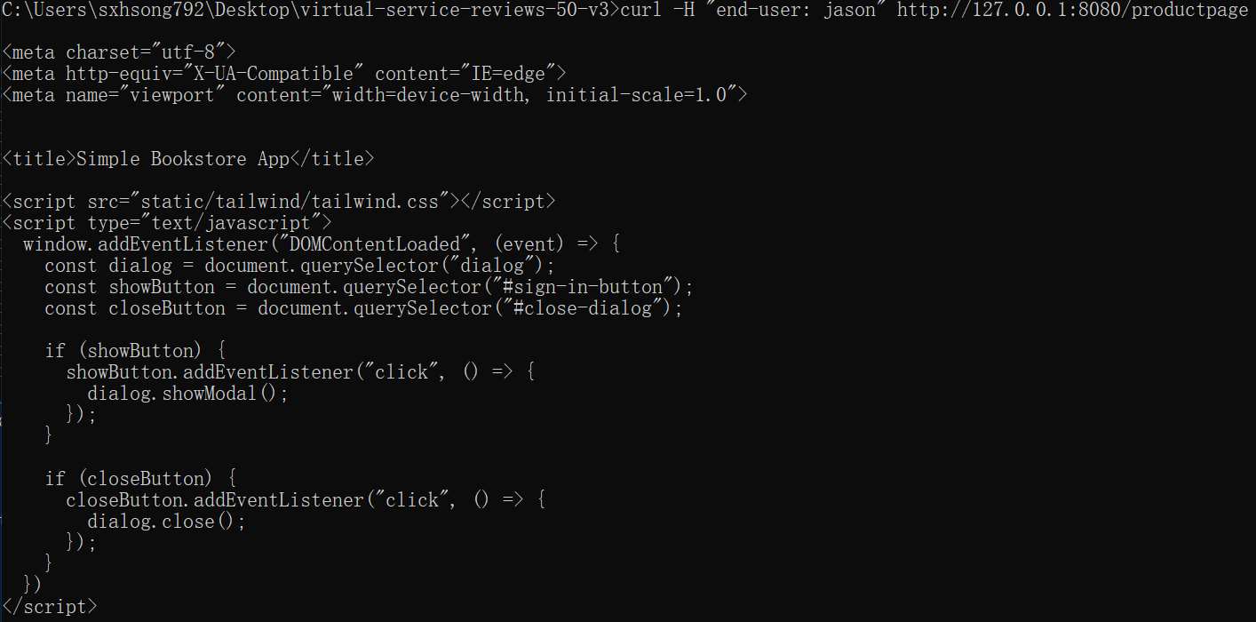

Injecting an HTTP delay fault

Create a fault injection rule to delay traffic coming from the test user jason

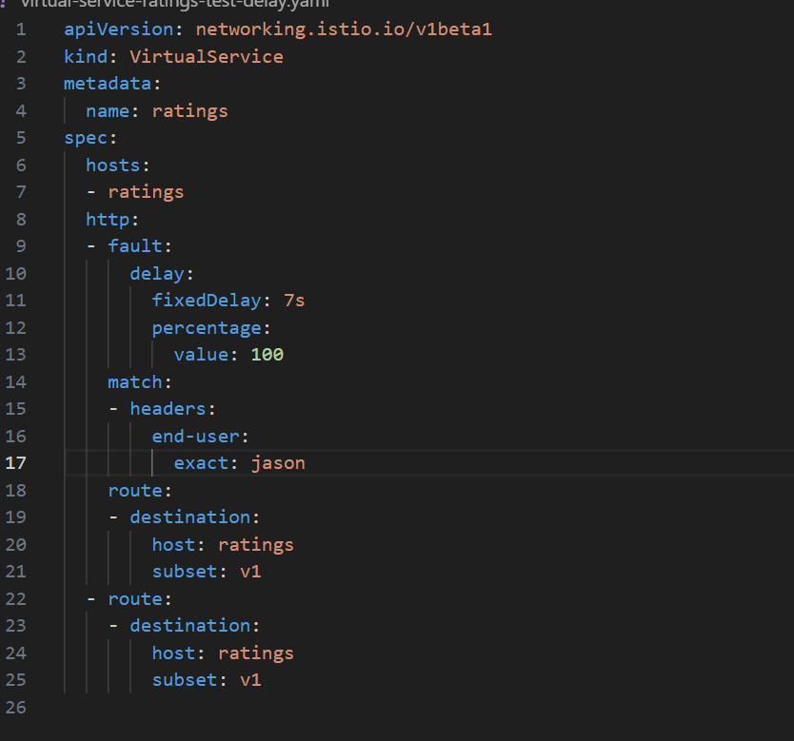

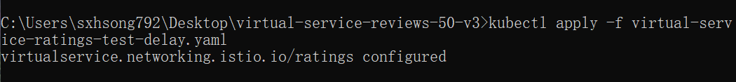

Confirm the rule was created:

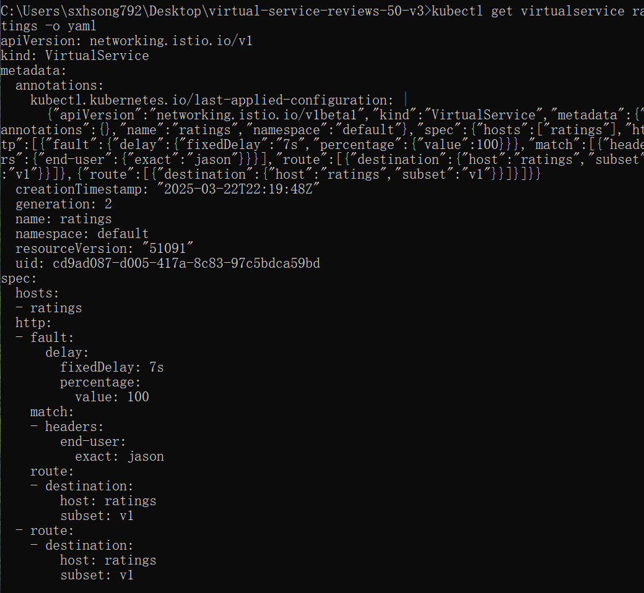

Testing the delay configuration

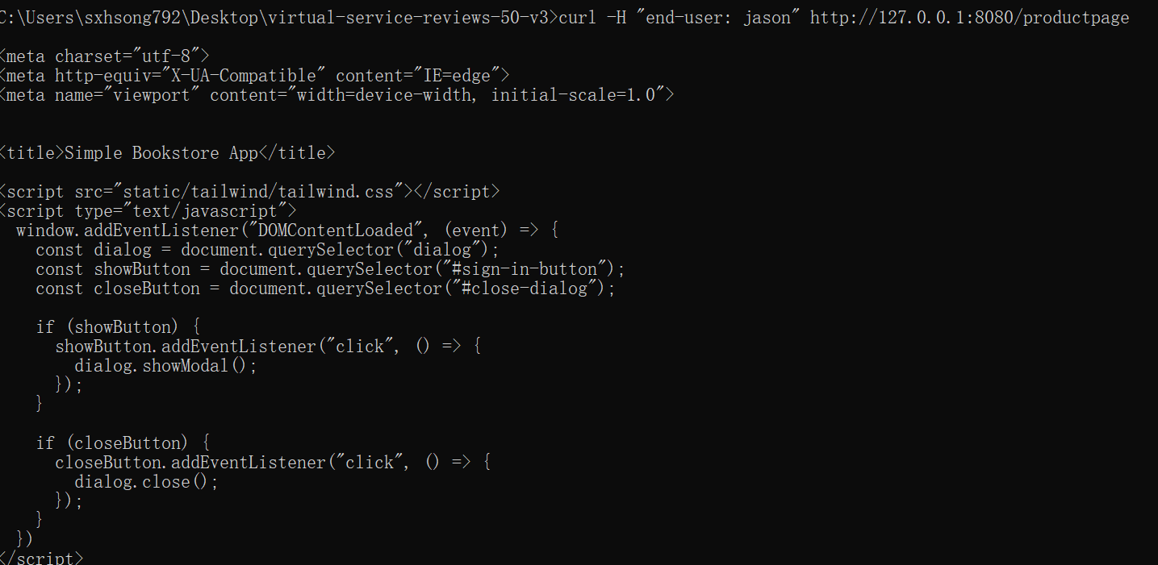

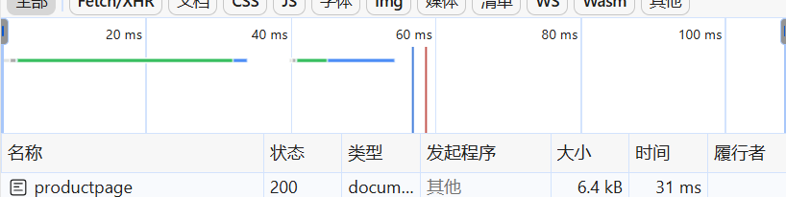

Fixing the bug

Create file

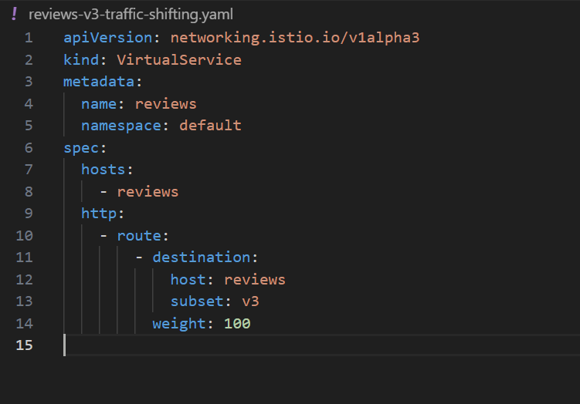

Apply it



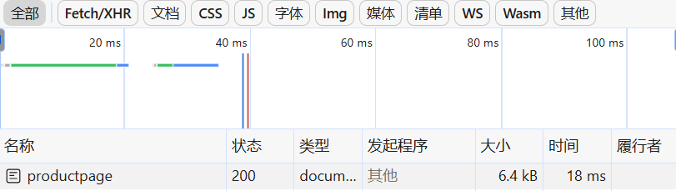

Injecting an HTTP abort fault

Create a fault injection rule to send an HTTP abort for user jason

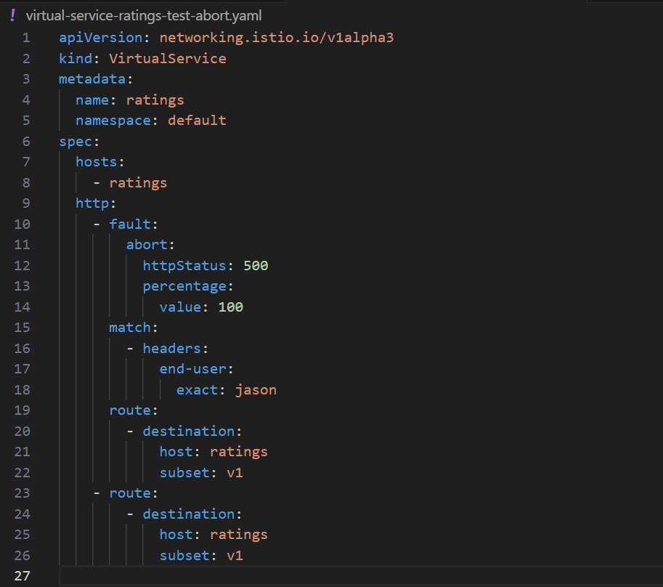



Confirm the rule was created:

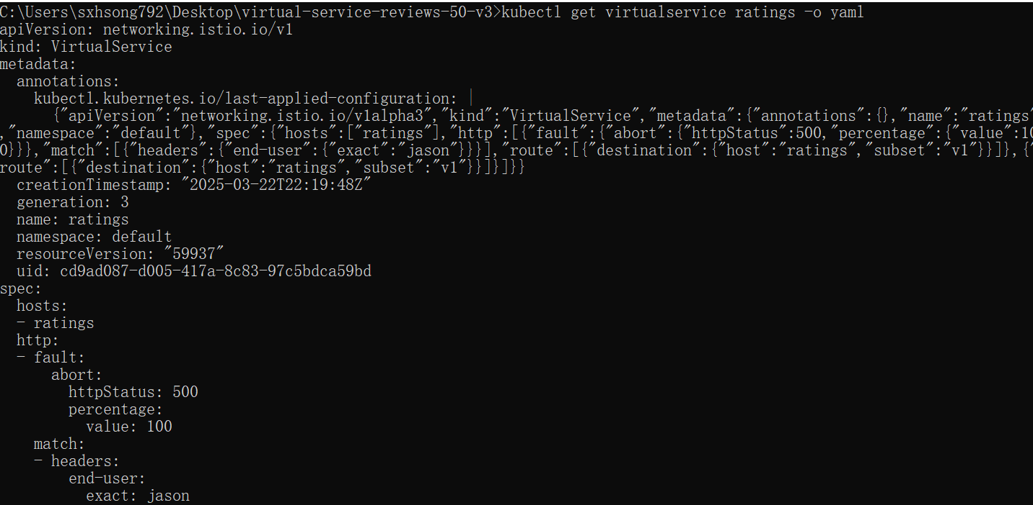

Testing the abort configuration

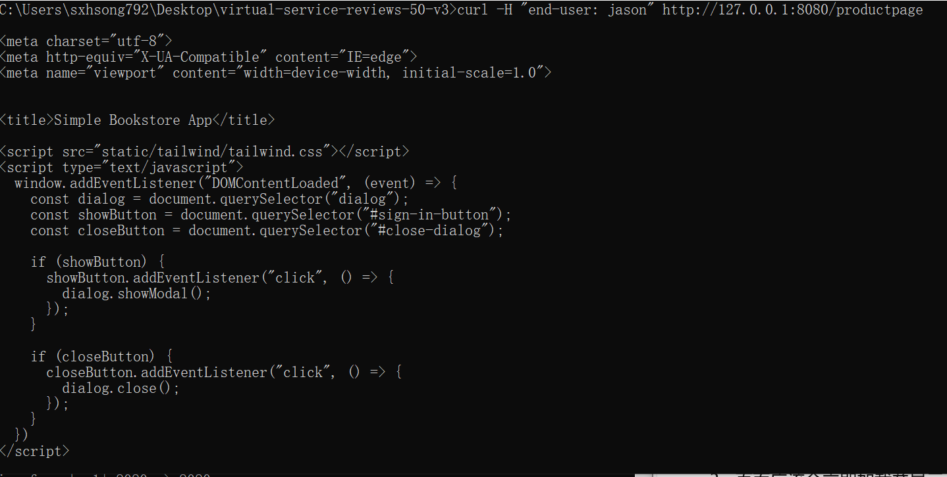

Configuring the circuit breaker

Create a destination rule to apply circuit breaking settings when calling the httpbin service

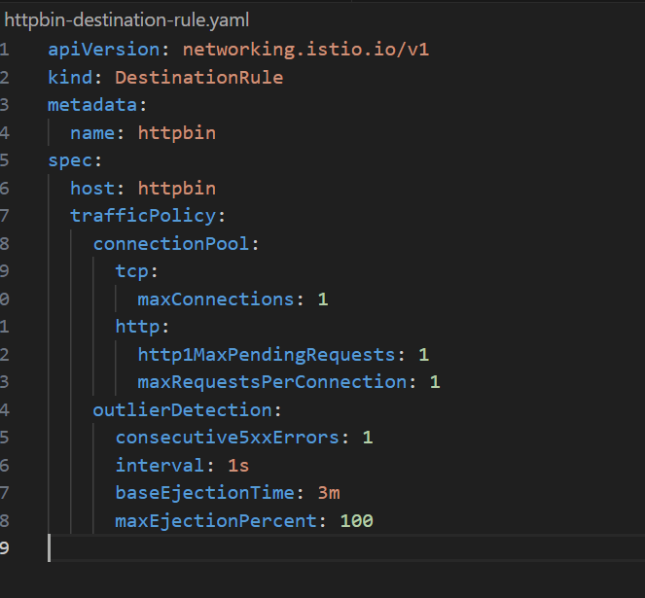

Verify the destination rule was created correctly:



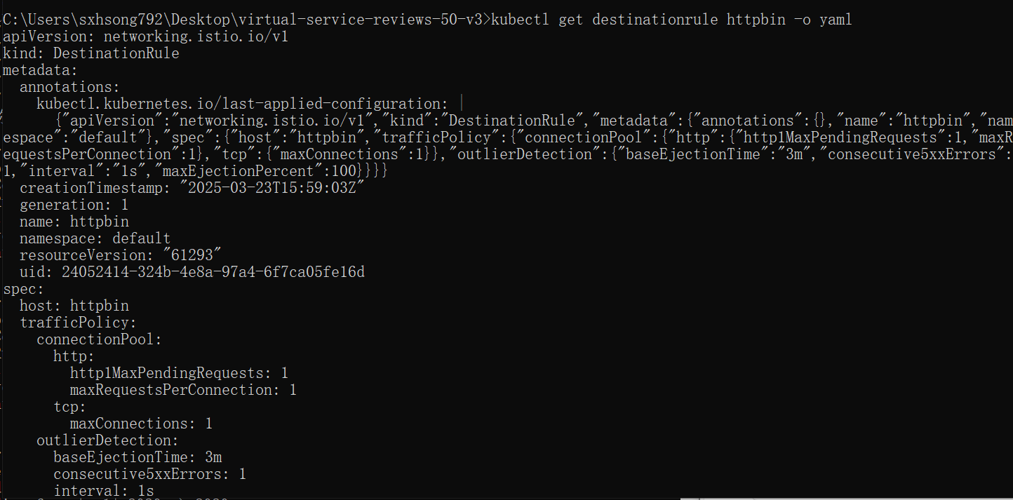

Adding a client

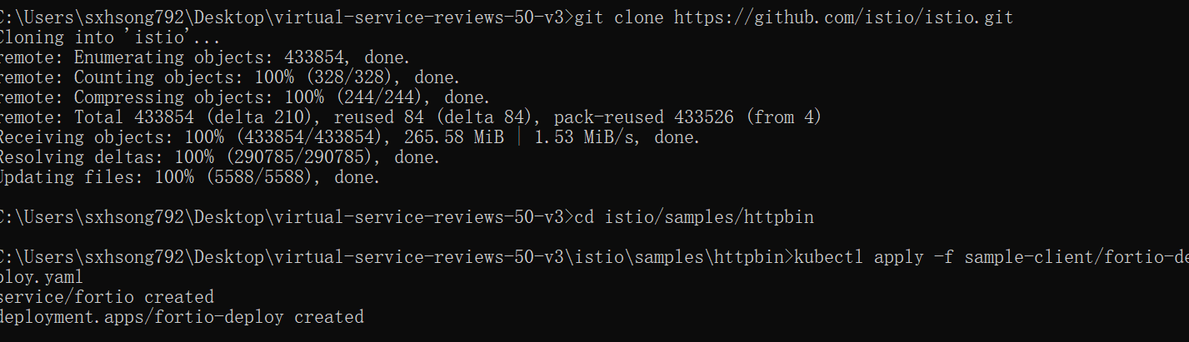

Log in to the client pod and use the fortio tool to call httpbin. Pass in curl to indicate that you just want to make one call:

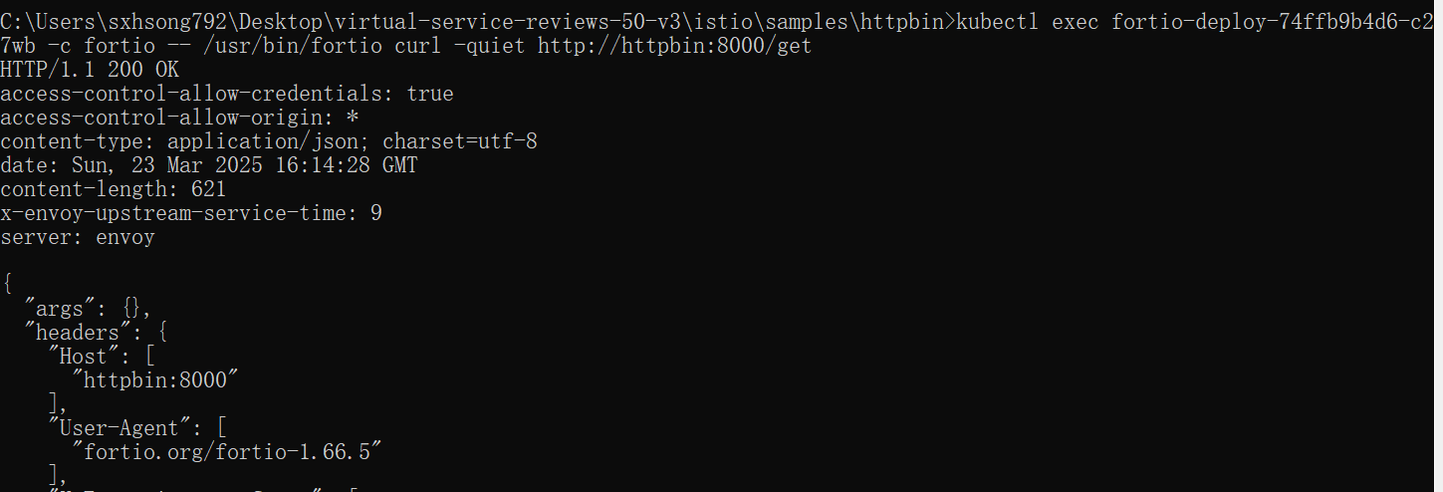

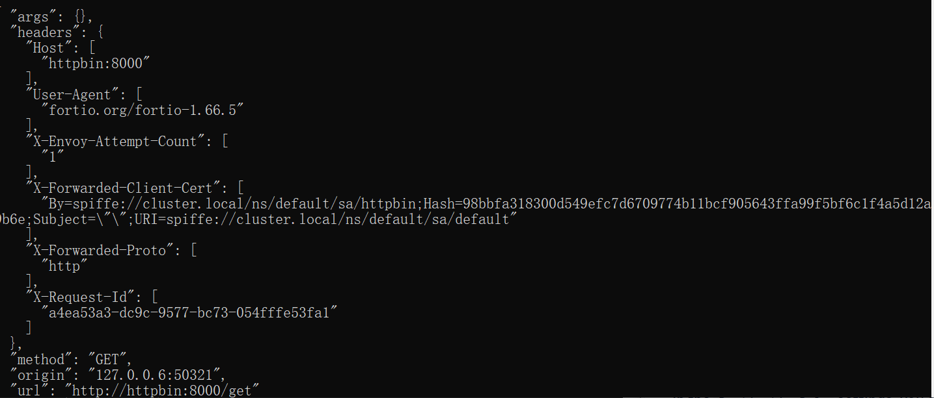

Tripping the circuit breaker

Call the service with two concurrent connections (-c 2) and send 20 requests (-n 20):

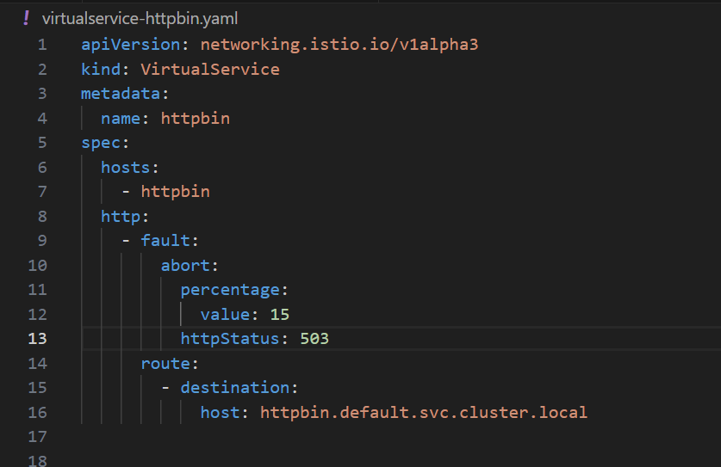

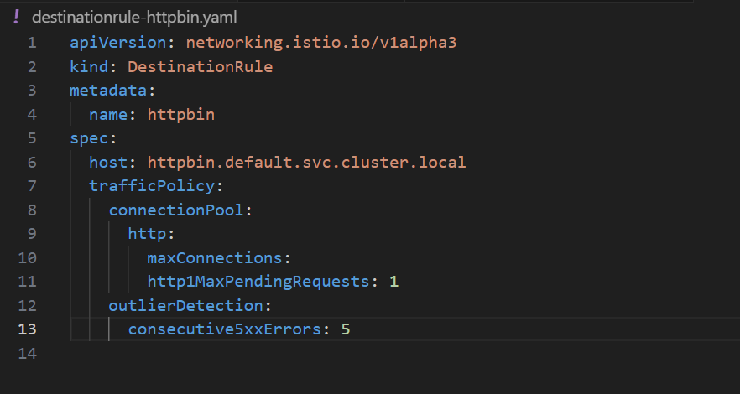

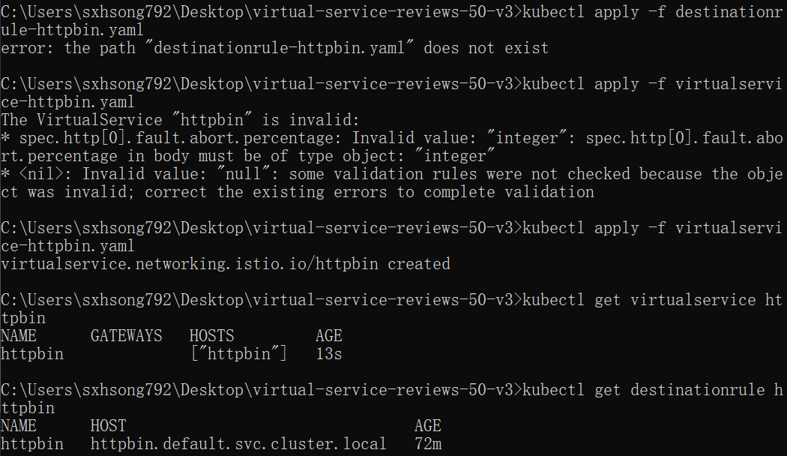

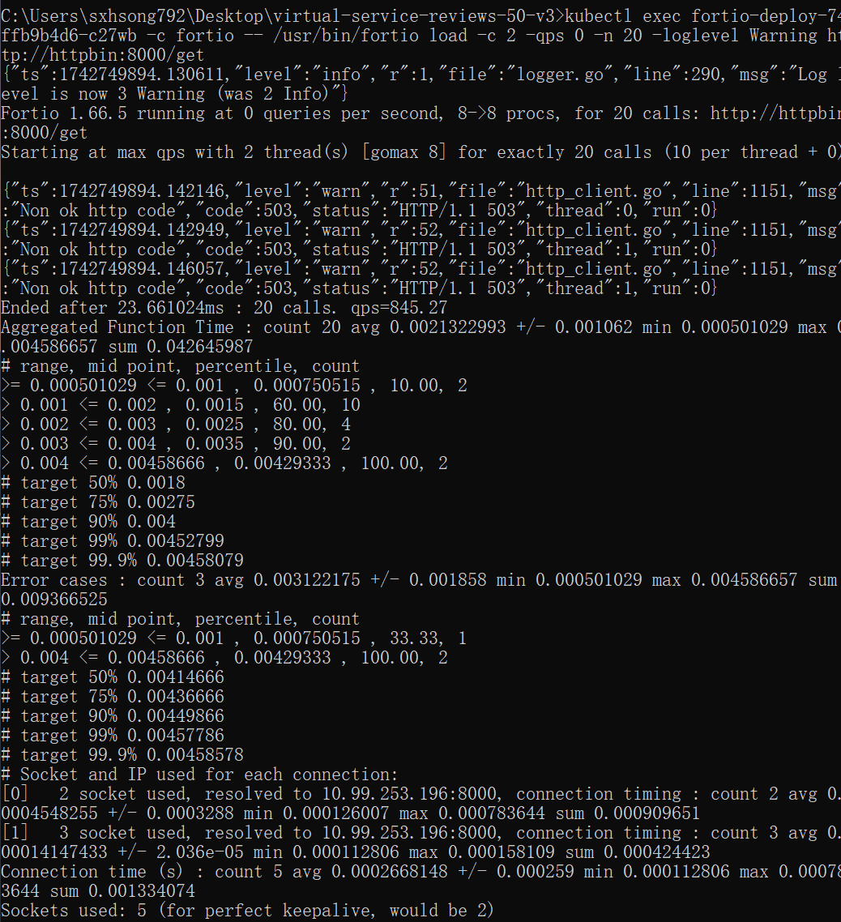

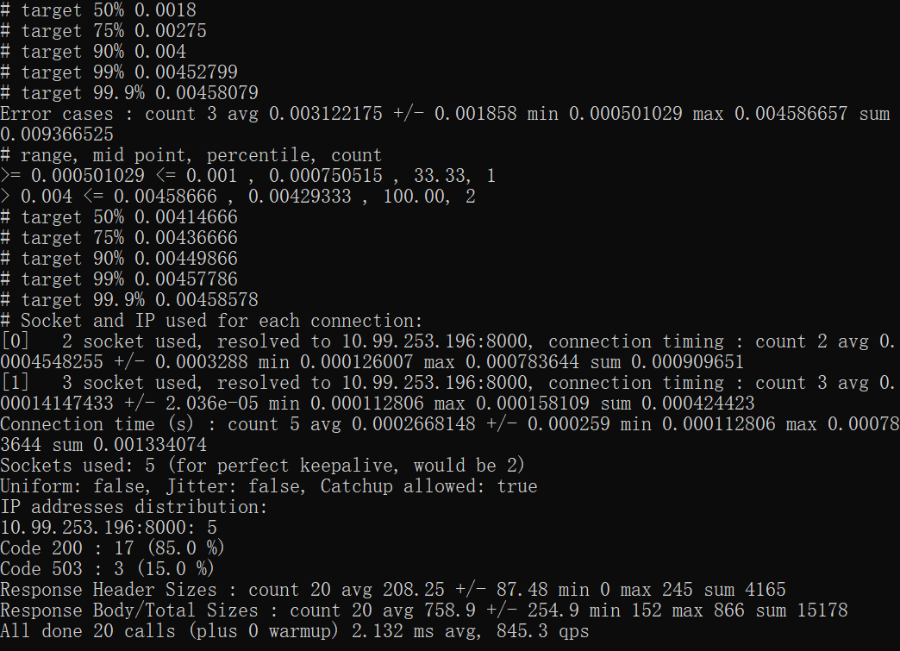

Almost all requests made it through! The istio-proxy does allow for some leeway.

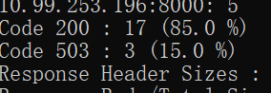

Bring the number of concurrent connections up to 3

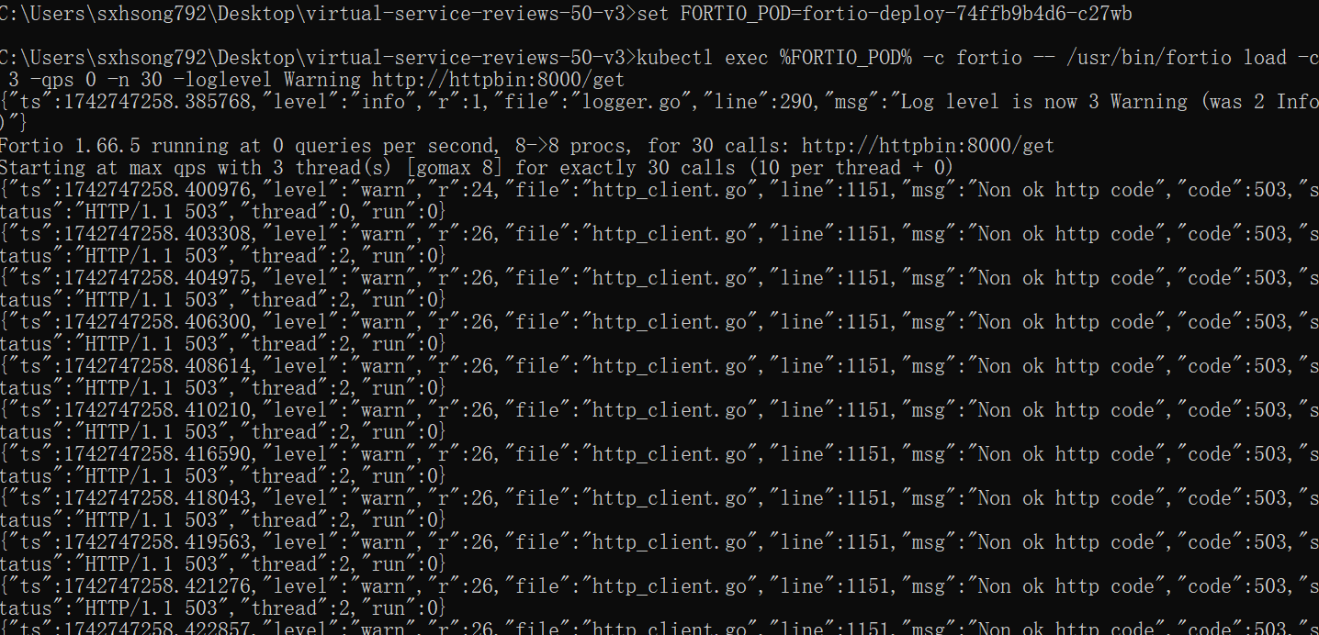

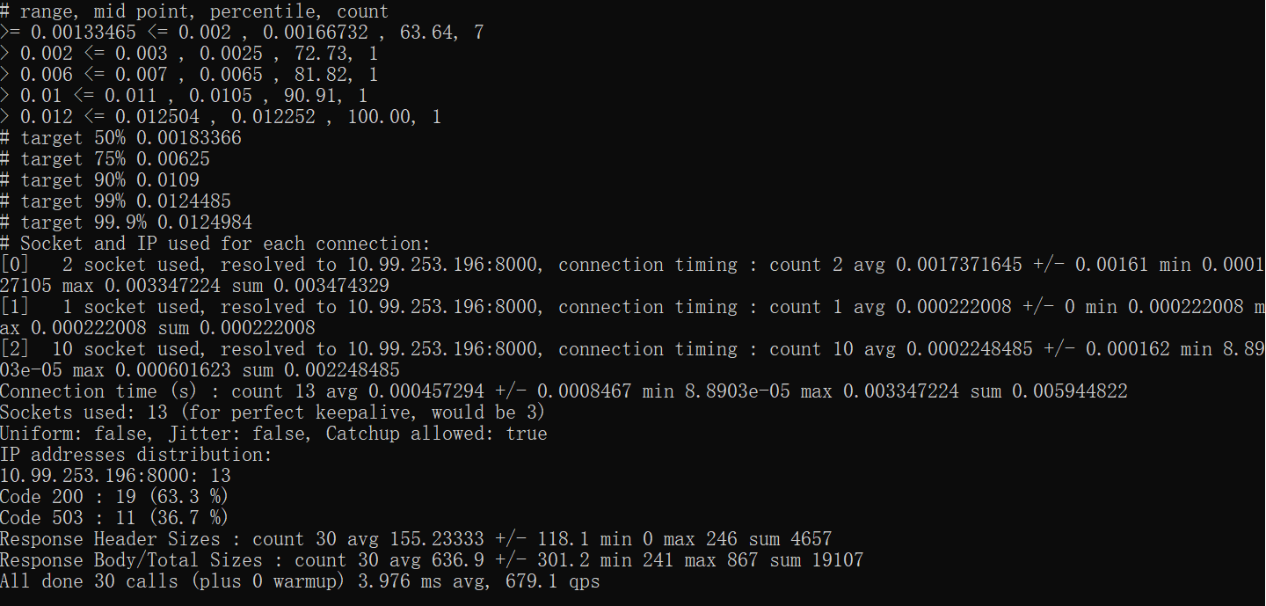

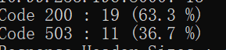

Query the istio-proxy stats to see more:

